Stroke Rehabilitation App

User Experience Report

# Intro

Strokes occur frequently every year and have detrimental ramifications on the survivors' brains, affecting their ability to function normally. According to the National Institution of Neurological Disorders and Stroke (2021), approximately 800,000 people suffer a stroke annually and about two-thirds of them survive and need rehabilitation to regain their functional capabilities. The severity of the brain damage determines the types of rehabilitation activities stroke survivors must undergo. Although there are various complications relating to strokes, the most common attributes of stroke patients are their reduced mobility, or ability to control certain muscle manoeuvres and cognitive impairment. The rehabilitation process for these aspects usually involves myriads of repetitions of simple exercises, which can be monotonous and therefore, a discouraging experience for the patients.

Although there have been a few apps designed for stroke rehabilitation purposes, namely the 'isquio Stroke Rehabilitation' (<https://play.google.com/store/apps/details?id=com.vk.isquio&hl=en_AU&gl=US>), this mobile application focuses on making the rehabilitation activities more enjoyable and encouraging. It "gamifies" the exercises, allowing users to have attainable goals, view their performance and share their progress with other people. The app will include two exercises, focusing on hands and fingers motions, in addition to cognitive capability. Since stroke patients have their movement and cognition impaired, they will only participate in the exercises while relying on their carers to navigate through the app.

# Usability Goals and Design Principles

## Elements that follow usability goals

**For Learnable on first use and Memorable on repeat uses**

* I designed the prototype adhering to iOS conventions to improve learnability for users, especially those who are familiar with iOS. The drawback of this approach is that Android and other OS users may find the app unorthodox and confusing.
* I placed tool-tip buttons to provide extra information about the functionalities, especially those that may be unclear to users (Figure 2.1).

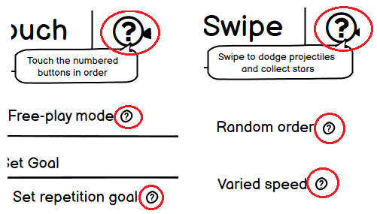

Figure 2.1. Examples of tool-tip button usage

* I kept my design consistent by providing a tab bar on every screen, except during gaming, and using conventional icons. For example, I adhered to iOS conventions by using the "Share" icon . This allows users who are familiar with iOS to instantly recognise its functionality.
* I added scroll bars for screens that are scrollable to aid users' learnability (Figure 2.2).

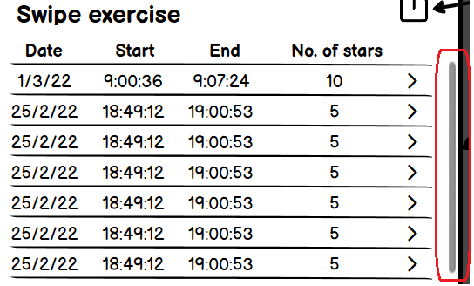

Figure 2.2. Examples of tool-tip button usage

**For Efficient**

* When the user finishes an exercise, the post-game screen will be displayed and give them the option to "Play Again" (with the same game mode and settings) (Figure 2.3). This reduces the number of clicks to reach the exercise phase, thus increasing the efficiency.

Figure 2.3. Post-game screen

* I deliberately did not include the functionality to allow the user to delete multiple records at once. This is because the purpose of the app is recording, and not deleting. In other words, deletion should only occur when it is necessary.

**For Failure-resistant**

* When the user clicks on the delete option, a warning dialogue box will be displayed to make sure the user confirms their action. This is to prevent the user from making serious mistakes.

Figure 2.4. The warning dialogue box for deletion

**For Forgiving**

* After a record has been deleted, an "Undo" deletion message will pop up and stay for 60 seconds (Figure 2.5), allowing the user to be able to restore the record if they accidentally deleted it (even after the warning box). This is to make it easy to recover from unwanted usage.



Figure 2.5. Undo option for deletion

**For Satisfying**

* The use of feedback from the "Undo" deletion message in Figure 2.5 makes the app more satisfying to use.
* Since the purpose of the app is to make repetitive exercises less wearisome, I added some game-like elements to my designed exercise ("Swipe"), where the user has to collect stars while dodging the projectiles (Figure 2.6).

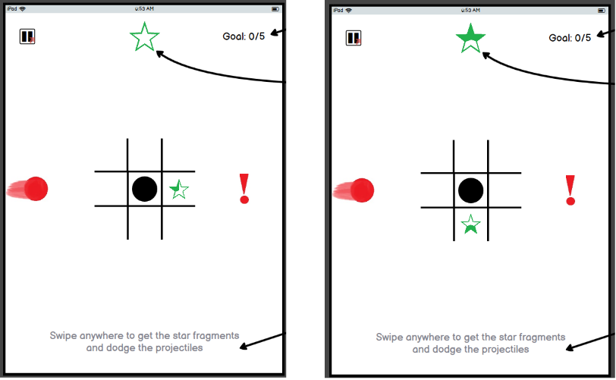

Figure 2.6. "Swipe" exercise demonstration

## Elements that follow Don Norman's design principles

**For Visibility**

* I enhanced visibility through the inclusion of a tab bar and heading on every screen, except during gaming (Figure 2.8). In addition, the currently selected tab is emphasized with blue, and the text is in bold.

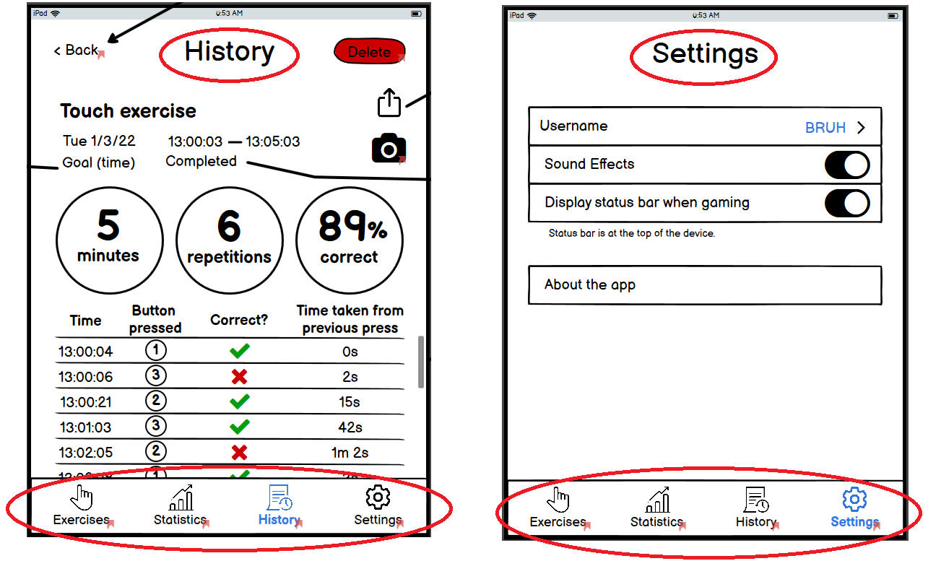

Figure 2.8. Tab bar and Heading inclusion

* For visibility, I displayed the value of sliders, as illustrated in Figure 2.9 below.

**For Consistency**

* As mentioned above, most elements in the prototype were designed adhering to iOS conventions for consistency. This helps users recognise patterns more easily, thereby facilitating usability.
* In addition, font sizes are consistent across screens for buttons, headings, and other texts, with a few minor exceptions. One example is the guidance text underneath a functionality (Figure 2.8).

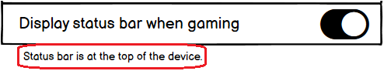

Figure 2.8. Guidance text with a smaller font size

* The inclusion of a tab bar and heading on every screen provides consistency throughout the app.

**Feedback**

* As mentioned above in the Forgiving section, an "Undo" deletion message will pop up to inform the user that a record has been successfully deleted (Figure 2.5).

**Affordance**

* Affordance is used throughout the app. Some examples are the use of a scroll bar to indicate a scrollable screen (Figure 2.2), the use of circles and rectangles for buttons, sliders for sliding values (Figure 2.9) and the use of arrows to indicate clickable content (Figure 2.10).



Figure 2.9. Buttons and sliders

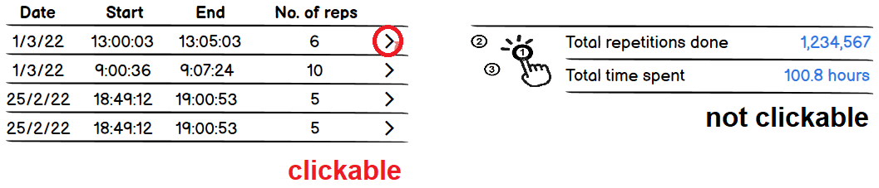

Figure 2.10. Clickable and unclickable content

**Constraints**

* The use of constraints is mostly through hiding unavailable functionalities in the current setting or mode. An example is hiding options for goal mode when the free-play mode is on (Figure 2.11).

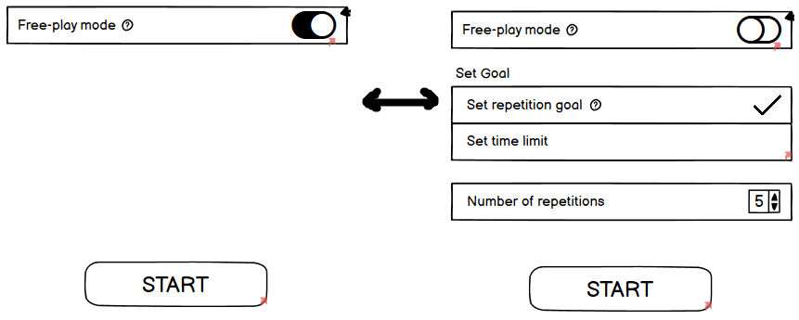

Figure 2.11. Hiding and showing available functionalities

**Mapping**

* Mapping was not heavily considered during the design process of the prototype.

# Testing Methodology

The app has been subjected to Usability testing with 5 participants, consisting of:

* 1 ICT students who also enrol in KIT305,
* 2 ICT student who does not enrol in KIT305,
* 2 non-student near-thirty adults, who frequently use mobile apps

This selection of users introduces bias because all participants have decent technological knowledge. It is especially more biased to select those who also enrol in KIT305 because they are knowledgeable about mobile development. In addition, they have had a general idea of what tasks to be expected before the testing session, thus would be more likely to perform tasks better than other individuals. As this app focuses on carers of the patients as its primary users, who would more likely be older, the Usability testing does not reflect the target population.

The tests were carried out both online, via Discord, and face-to-face. They were conducted similarly, with only one difference:

* For face-to-face tests, I gave the test tasks to users, and they perform the tasks by themselves
* For online tests, I sent the users test tasks, shared my screen so I could do the navigation through the prototype for the users, according to their instructions

The testing process was as follows:

1. I explained the purpose of the app and the procedure of the test
   * I also asked the participants to think out loud while doing the task, with a quick demonstration on how to do it
2. I gave the Usability test tasks to the participants
3. For each task:
   * I set up the corresponding screen for starting
     + Most tasks will occur at the start screen
     + T4 and T5 will be when they are playing the game, rather than the start screen
   * I started the timer when the participants started reading the task and stopped when I confirmed that they had reached the intended functionality
   * As the participants performed the tasks, I observed their clicks and cleared any confusion in the wording of the tasks
     + I did not assist with any questions regarding how to perform the tasks
   * If the task took much longer than I expected, I asked them to elaborate, so I could gain more insight into the problem
   * At the end of a task, I asked for their comments before continuing on the next task
4. After all the tasks had been done, I asked if they have any suggestions for a better design and concluded the session

The Success Requirements, Usability Test Tasks and Test Tasks Matrix are as follows:

Success Requirements

|  |  |
| --- | --- |
| R1 | Start an exercise on free-play mode |
| R2 | Start an exercise on goal mode (repetition/star count) |
| R3 | Start an exercise on goal mode (time limit) |
| R4 | Customise difficulty for an exercise |
| R5 | View your stats |
| R6 | View history of all attempts of an exercise |
| R7 | Share all attempts of an exercise |
| R8 | View a specific attempt of an exercise |
| R9 | Share a specific attempt of an exercise |
| R10 | Delete an attempt of an exercise |
| R11 | Associate an image with an attempt at an exercise |
| R12 | Change your username |

Test tasks

|  |  |
| --- | --- |
| T1 | Your patient doesn’t have a specific aim for any exercise in mind and just want a casual practice. Set the appropriate mode for the "Touch" exercise and begin exercise so your patient can play without stopping. |
| T2 | You want your patient to practice their finger movements in the "Touch" exercise for 30 minutes today. Do it. |
| T3 | Your patient wants to see how fast they can collect 10 stars in the "Swipe" game. Start the game for them. |
| T4 | Your patient is doing the "Touch" exercise and finds having 3 buttons quite simple. Increase the number of buttons to 5. |
| T5 | Your patient is doing the "Swipe" exercise and wants to have more projectiles. Change it so the game has 2 projectiles. |
| T6 | Your patient has completed a lot of exercises lately. Check the number of repetitions in total they have completed for the "Touch" exercise. |
| T7 | Your patient has completed many exercises in the past few days. Check how many attempts of the "Swipe" exercise they have completed in the past week. |
| T8 | You need your patient's record for a third-party application. Export the entire records of the "Swipe" exercise that they have completed. |
| T9 | Your patient has made a lot of mistakes in the most recent "Touch" exercise. View the list of buttons pressed in that attempt. |
| T10 | In the most recent attempt at the "Swipe" exercise, your patient had to stop midway through. Delete that attempt. |
| T11 | Your patient has just completed their best attempt of the "Touch" exercise today. Share the record with their family. |
| T12 | Your patient has just completed an amazing attempt of "Touch" exercise and wants to have something to remember it. Take their selfie to associate with it. |
| T13 | You do not like how the name is displayed as "BRUH" when you first open the app. Change it to the name you want. |

Test tasks Matrix

|  |  |  |  |  |  |  |  |  |  |  |  |  |
| --- | --- | --- | --- | --- | --- | --- | --- | --- | --- | --- | --- | --- |
|  | Free play  mode | Goal mode (count) | Goal mode  (time limit) | Customise difficulty | View  stats | History of  all | Share  all | View  specific | Share  specific | Delete  attempt | Associate  image | Change  name |
| R1 | R2 | R3 | R4 | R5 | R6 | R7 | R8 | R9 | R10 | R11 | R12 |
| T1 | x |  |  |  |  |  |  |  |  |  |  |  |
| T2 |  |  | x |  |  |  |  |  |  |  |  |  |
| T3 |  | x |  |  |  |  |  |  |  |  |  |  |
| T4 |  |  |  | x |  |  |  |  |  |  |  |  |
| T5 |  |  |  | x |  |  |  |  |  |  |  |  |
| T6 |  |  |  |  | x |  |  |  |  |  |  |  |
| T7 |  |  |  |  |  | x |  |  |  |  |  |  |
| T8 |  |  |  |  |  | x | x |  |  |  |  |  |
| T9 |  |  |  |  |  |  |  | x |  |  |  |  |
| T10 |  |  |  |  |  |  |  | x |  | x |  |  |
| T11 |  |  |  |  |  |  |  | x | x |  |  |  |
| T12 |  |  |  |  |  |  |  | x |  |  | x |  |
| T13 |  |  |  |  |  |  |  |  |  |  |  | x |

# Testing Results and Discussion

The results of time taken (in seconds) are as follows:

|  |  |  |  |  |  |  |  |  |
| --- | --- | --- | --- | --- | --- | --- | --- | --- |
|  | User 1 | User 2 | User 3 | User 4 | User 5 | Min | Max | Mean |
| T1 (play free-play) | 31 | 45 | 42 | 40 | 46 | 31 | 46 | 40.8 |
| T2 (play with time-limit) | 15 | 14 | 25 | 20 | 22 | 14 | 25 | 19.2 |
| T3 (play with count goal) | 22 | 34 | 22 | 16 | 23 | 16 | 34 | 23.4 |
| T4 (customise difficulty) | 22 | 24 | 17 | 22 | 23 | 17 | 24 | 21.6 |
| T5 (customise difficulty) | 20 | 16 | 8 | 12 | 15 | 8 | 20 | 14.2 |
| T6 (View stats) | 21 | 25 | 22 | 27 | 16 | 16 | 27 | 22.2 |
| T7 (View all history) | 29 | 30 | 22 | 25 | 25 | 22 | 30 | 26.2 |
| T8 (Share all history) | 37 | 65 | 23 | 26 | 31 | 23 | 65 | 36.4 |
| T9 (View a specific record) | 25 | 50 | 23 | 34 | 25 | 23 | 50 | 31.4 |
| T10 (Delete a record) | 22 | 40 | 16 | 23 | 20 | 16 | 40 | 24.2 |
| T11 (Share a specific record) | 30 | 22 | 19 | 13 | 15 | 13 | 30 | 19.8 |
| T12 (Add image to a record) | 23 | 25 | 19 | 16 | 19 | 16 | 25 | 20.4 |
| T13 (Change name) | 19 | 12 | 13 | 10 | 12 | 10 | 19 | 13.2 |

According to the result table above, when the users had explored the tab, they generally finished following tasks on that screen more quickly. This corresponds to the "Memorable on repeat use" Usability goal.

I have made many changes to the prototype based on my observations from the Usability tests and user feedback. Here are some of the features that improve the usability of the application:

1. I set the free-play mode to OFF for default. Previously, when the user clicks on the exercise, it displayed the "free-play mode" screen as the default (Figure 4.1). This hindered the visibility of other available options. In the improved version, I turned off the free-play mode for default, to inform the user of other options (Figure 4.2). This corresponds to Don Norman's Visibility principle.

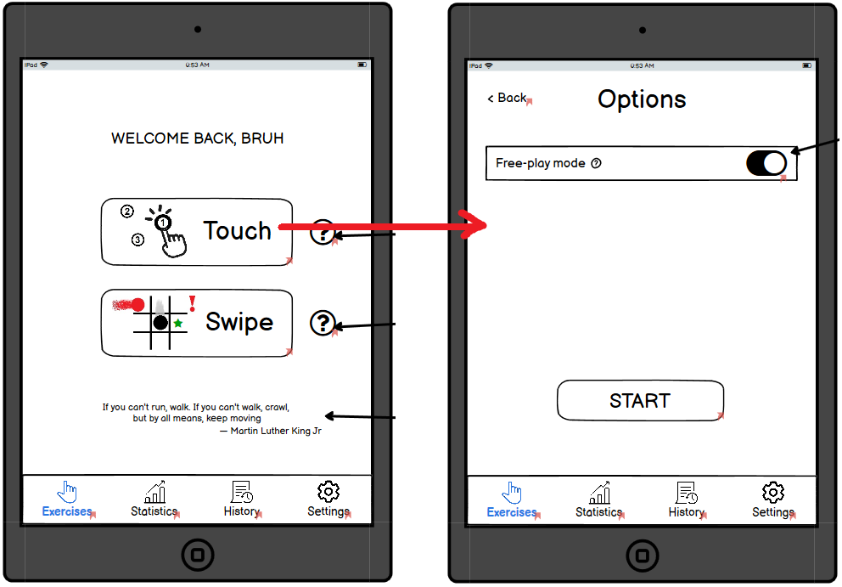

Figure 4.1. Exercises screen to Exercise Options screen (previous version)

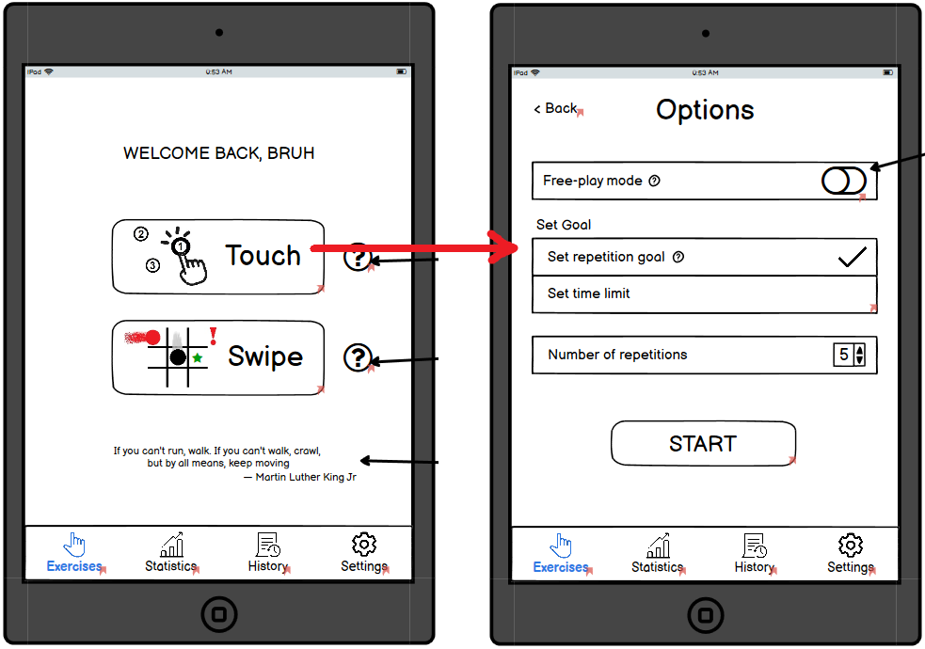

Figure 4.2. Exercises screen to Exercise Options screen (improved version)

1. I added a "How to Play" screen for Exercise 2 ("Swipe") as the rules may be confusing at first. This screen will appear only once when the user first plays the game. This corresponds to the "Learnable on first use" Usability goal.

Figure 4.3. How to Play screen for "Swipe" exercise

1. I changed the "Pause " icon  to a "Cross" icon  when the game is paused (Figure 4.4). This is to inform the user of a different function. This corresponds to Don Norman's Affordance principle, as the "Cross" icon  gives clue that it is to turn off the Pause menu. Another solution is to remove the above-mentioned button entirely and the "Resume" button is the only way to turn off the Pause menu and continue the game.

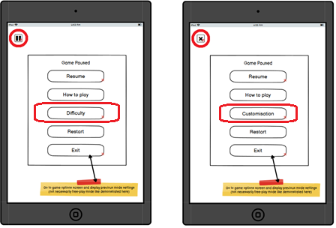

Figure 4.4. Game pause screen (previous – left, improved – right)

1. In the Pause screen, I changed the wording of "Difficulty" to "Customisation" (Figure 4.4). This is because the word "Difficulty" does not reflect every setting within, namely the "Next-button indication" (Figure 4.5).

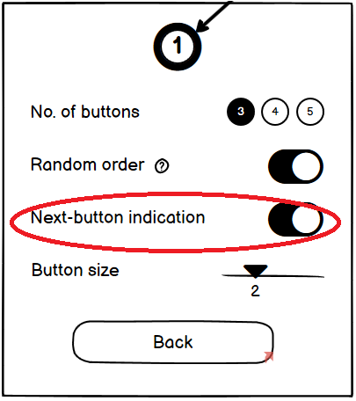

Figure 4.5. "Touch" game customisation

1. In the "History" tab, I changed the Share icon  to the text with an underline, to indicate a clickable feature (Figure 4.6). Another design idea is to have a "Share" button or a drop-down menu with additional functionalities.

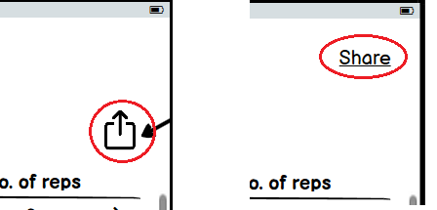

Figure 4.6. "Share all records" functionality in the "History" tab

1. In the screen for a specific record, I joined all the functionalities into a drop-down menu, with the delete option at the bottom and in red. This increases screen space for better visibility.

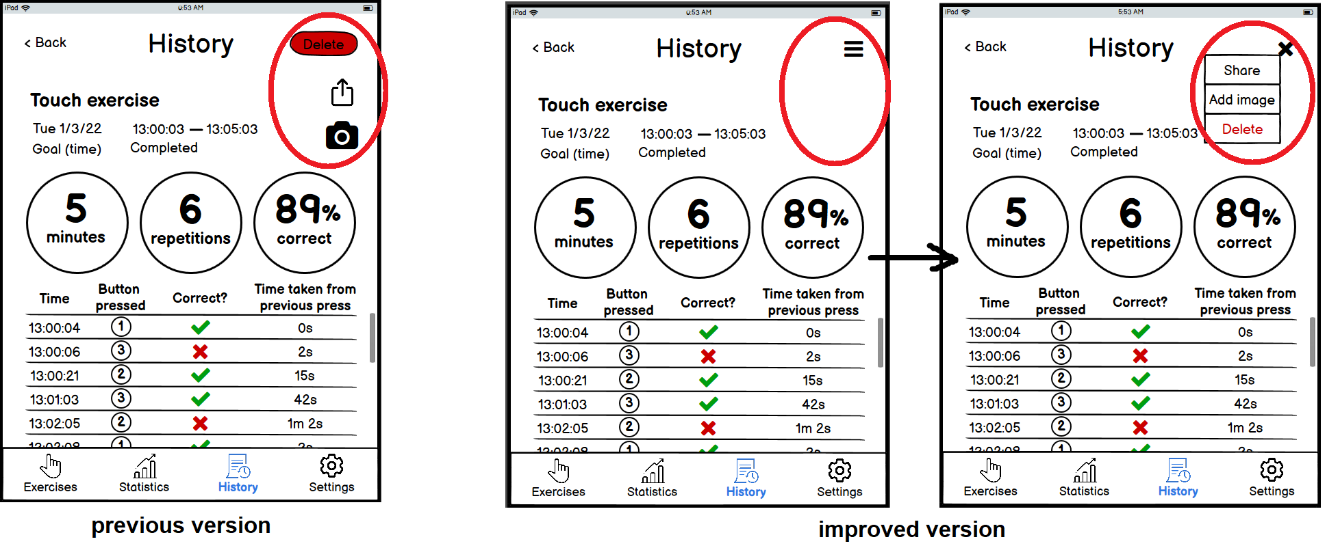

Figure 4.7. Functionalities within a specific record screen (previous – left, improved – right)

1. In the improved version, when a deletion warning dialogue box is displayed, all other buttons will become unclickable. This is to restrict the range of possible actions (Don Norman's Constraints principle), making the app more failure resistant.

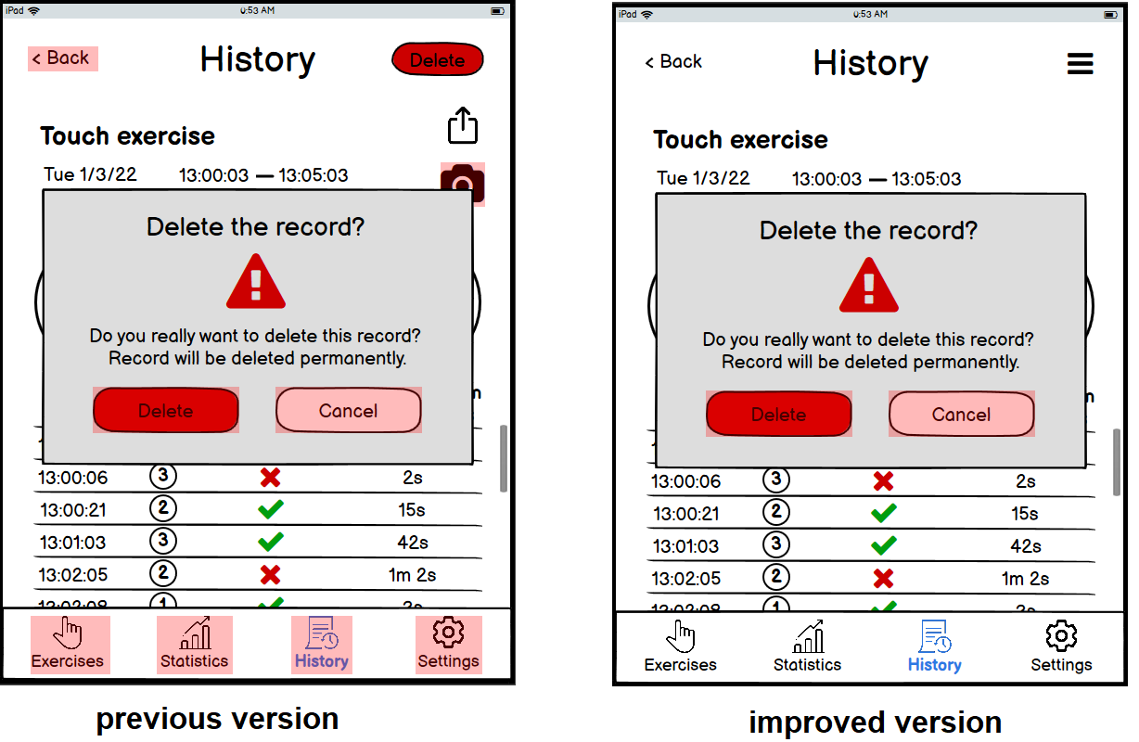

Figure 4.7. Functionalities within a specific record screen (previous – left, improved – right)

# Conclusion

Mental models vary among people, different individuals can have different ideas on how the interface of an app should be designed (Wells, L 2022). Therefore, usability testing is crucial for the prototyping process as it gives insight into how users interact with and navigate through the mobile app, so the designer can make changes accordingly and improve the usability (Morgan, K 2019).

# References

Apple 2022, 'Tab Bars', Human Interface Guidelines, viewed 16 March 2022. Available at: <https://developer.apple.com/design/human-interface-guidelines/ios/bars/tab-bars/>

Babich, N (2016), 'The Golden Rules of Bottom Navigation Design', Smashing Magazine, 2 November, viewed 17 March 2022. Available at: <https://www.smashingmagazine.com/2016/11/the-golden-rules-of-mobile-navigation-design/>

InsightfulHealthcare, 'isquio Stroke Rehabilitation', Google Play, 15 January, viewed 9 March 2022. Available at: <https://play.google.com/store/apps/details?id=com.vk.isquio&hl=en_AU&gl=US>

Morgan, K (2019), ' Usability Testing 101', Nielsen Norman Group, 1 December, viewed 13 March 2022. Available at: <https://www.nngroup.com/articles/usability-testing-101/>

National Institution of Neurological Disorders and Stroke (2021), 'Post-Stroke Rehabilitation Fact Sheet', 15 November, viewed 17 March 2022. Available at: <https://www.ninds.nih.gov/Disorders/Patient-Caregiver-Education/Fact-Sheets/Post-Stroke-Rehabilitation-Fact-Sheet>

Netmag (2014), ' Why people focus on the right-hand side of a design ', 18 March, viewed 17 March 2022. Available at: <https://www.creativebloq.com/netmag/why-people-focus-right-hand-side-design-3146267>

Wells, L (2022), 'Introduction, Prototyping, and Design' lecture slides, MyLO KIT305. Available at: <https://mylo.utas.edu.au/d2l/le/content/505363/viewContent/4315227/View>

Wells, L (2022), ' Usability Testing' lecture slides, MyLO KIT305. Available at: <https://mylo.utas.edu.au/d2l/le/content/505363/viewContent/4315228/View>

# Appendices

Results from think-alouds during usability tests:

T1: Your patient doesn’t have a specific aim for any exercise in mind and just want a casual practice. Set the appropriate mode for the "Touch" exercise and begin exercise so your patient can play without stopping.

|  |  |  |  |  |
| --- | --- | --- | --- | --- |
|  | Success | Time taken | Observations | User comments |
| User 1 | Yes | 31s |  | * Consider having a motivational quote in the front screen |
| User 2 | Yes | 45s |  | * Wording is a bit confusing |
| User 3 | Yes | 42s | * Try to click on all modes | * Consider changing the text "Options" to "Touch / Swipe Options" (or "Mode") * Consider changing names of 2 exercises |
| User 4 | Yes | 40s |  | No comments |
| User 5 | Yes | 46s | * Try to click on all modes | No comments |

T2: You want your patient to practice their finger movements in the "Touch" exercise for 30 minutes today. Do it.

|  |  |  |  |  |
| --- | --- | --- | --- | --- |
|  | Success | Time taken | Observations | User comments |
| User 1 | Yes | 15s |  | No comments |
| User 2 | Yes | 14s |  | No comments |
| User 3 | Yes | 25s | * Click tooltip | * Should display all modes / options when user clicks exercise |
| User 4 | Yes | 20s |  | No comments |
| User 5 | Yes | 22s |  | No comments |

T3: Your patient wants to see how fast they can collect 10 stars in the "Swipe" game. Start the game for them.

|  |  |  |  |  |
| --- | --- | --- | --- | --- |
|  | Success | Time taken | Observations | User comments |
| User 1 | Yes | 22s |  | No comments |
| User 2 | Yes | 34s |  | No comments |
| User 3 | Yes | 22s |  | * Should display all modes / options when user clicks exercise |
| User 4 | Yes | 16s |  | No comments |
| User 5 | Yes | 23s |  | No comments |

T4: Your patient is doing the "Touch" exercise and finds having 3 buttons quite simple. Increase the number of buttons to 5.

|  |  |  |  |  |
| --- | --- | --- | --- | --- |
|  | Success | Time taken | Observations | User comments |
| User 1 | Yes | 22s |  | No comments |
| User 2 | Yes | 24s |  | * Pause button should be changed to settings icon |
| User 3 | Yes | 17s |  | No comments |
| User 4 | Yes | 22s |  | * Should change "Difficulty" text to "Customisation" |
| User 5 | Yes | 23s |  | No comments |

T5: Your patient is doing the "Swipe" exercise and wants to have more projectiles. Change it so the game has 2 projectiles.

|  |  |  |  |  |
| --- | --- | --- | --- | --- |
|  | Success | Time taken | Observations | User comments |
| User 1 | Yes | 20s |  | No comments |
| User 2 | Yes | 16s |  | * Wording can be improved |
| User 3 | Yes | 8s |  | No comments |
| User 4 | Yes | 12s |  | No comments |
| User 5 | Yes | 15s |  | No comments |

T6: Your patient has completed a lot of exercises lately. Check the number of repetitions in total they have completed for the "Touch" exercise.

|  |  |  |  |  |
| --- | --- | --- | --- | --- |
|  | Success | Time taken | Observations | User comments |
| User 1 | Yes | 21s | * Click on the "History" tab | No comments |
| User 2 | Yes | 25s |  | No comments |
| User 3 | Yes | 22s | * Click on the "History" tab | * Wording can be better |
| User 4 | Yes | 27s | * Click on the "History" tab | No comments |
| User 5 | Yes | 16s |  | No comments |

T7: Your patient has completed many exercises in the past few days. Check how many attempts of the "Swipe" exercise they have completed in the past week.

|  |  |  |  |  |
| --- | --- | --- | --- | --- |
|  | Success | Time taken | Observations | User comments |
| User 1 | Yes | 29s |  | No comments |
| User 2 | Yes | 30s |  | No comments |
| User 3 | Yes | 22s |  | * Consider having a count number for day, week, month 🡪 easier to track progress |
| User 4 | Yes | 25s |  | No comments |
| User 5 | Yes | 25s |  | No comments |

T8: You need your patient's record for a third-party application. Export the entire records of the "Swipe" exercise that they have completed.

|  |  |  |  |  |
| --- | --- | --- | --- | --- |
|  | Success | Time taken | Observations | User comments |
| User 1 | Yes | 37s | * Try the "Share your stats" button in Statistics tab | * The "Share your stats" can be confusing |
| User 2 | Yes – with help | 1m 5s | * Try the "Share your stats" button in Statistics tab | * Consider changing icon into text * Put it outside the main History screen |
| User 3 | Yes | 23s |  | No comments |
| User 4 | Yes | 26s |  | * Should put share functionality outside the main History screen |
| User 5 | Yes | 31s |  | * In the main History screen, should only have 2 buttons for each exercise, then access records for each (more streamlined flow) |

T9: Your patient has made a lot of mistakes in the most recent "Touch" exercise. View the list of buttons pressed in that attempt.

|  |  |  |  |  |
| --- | --- | --- | --- | --- |
|  | Success | Time taken | Errors | User comments |
| User 1 | Yes | 25s |  | * Should have "Buttons pressed" heading to make it clearer |
| User 2 | Yes | 50s |  | No comments |
| User 3 | Yes | 23s |  | No comments |
| User 4 | Yes | 34s |  | * Should add heading to indicate start of list |
| User 5 | Yes | 25s |  | No comments |

T10: In the most recent attempt of the "Swipe" exercise, your patient had to stop midway through. Delete that attempt.

|  |  |  |  |  |
| --- | --- | --- | --- | --- |
|  | Success | Time taken | Errors | User comments |
| User 1 | Yes | 22s |  | * Share, delete, and camera buttons are too close 🡪 can mis-click |
| User 2 | Yes | 40s |  | * Consider joining all functions together |
| User 3 | Yes | 16s |  | * Consider joining all functionalities in drop-down menu |
| User 4 | Yes | 23s |  | No comments |
| User 5 | Yes | 20s |  | * Drop-down menu |

T11: Your patient has just completed their best attempt of the "Touch" exercise today. Share the record with their family.

|  |  |  |  |  |
| --- | --- | --- | --- | --- |
|  | Success | Time taken | Errors | User comments |
| User 1 | Yes | 30s |  | No comments |
| User 2 | Yes | 22s |  | No comments |
| User 3 | Yes | 19s |  | No comments |
| User 4 | Yes | 13s |  | No comments |
| User 5 | Yes | 15s |  | No comments |

T12: Your patient has just completed an amazing attempt of "Touch" exercise and wants to have something to remember it. Take their selfie to associate with it.

|  |  |  |  |  |
| --- | --- | --- | --- | --- |
|  | Success | Time taken | Observations | User comments |
| User 1 | Yes | 23s |  | No comments |
| User 2 | Yes | 25s |  | No comments |
| User 3 | Yes | 19s |  | * Should be able to change the photo 🡪 indicate clickable * Photo and Share buttons are too close 🡪 drop down menu is better |
| User 4 | Yes | 16s |  | No comments |
| User 5 | Yes | 19s |  | No comments |

T13: You do not like how the name is displayed as "BRUH" when you first open the app. Change it to the name you want.

|  |  |  |  |  |
| --- | --- | --- | --- | --- |
|  | Success | Time taken | Observations | User comments |
| User 1 | Yes | 19s |  | No comments |
| User 2 | Yes | 12s |  | No comments |
| User 3 | Yes | 13s |  | No comments |
| User 4 | Yes | 10s |  | No comments |
| User 5 | Yes | 12s |  | No comments |